Exp No 7: Demonstrate Virtualization By Installing Type-2 Hypervisor In Your Device, Create And Configure Vm Image With A Host Operating System (Either Windows/Linux).
Date:
Aim:
To Demonstrate Virtualization By Installing Type-2 Hypervisor In Your Device, Create And Configure Vm Image With A Host Operating System (Either Windows/Linux).
Procedure:
Step 1:Dowload Vmware Workstation And Installed As Type 2hypervisor.
Step2:Dowload Ubuntu Or Tiny Os As Iso Image File. Step 3: In Vmware Workstation->Create New Vm. Step 4: Do The Basic Configuration Settings.
Step 5: Created Tiny Os Virtual Machine. Step 6: Launch The Vm.

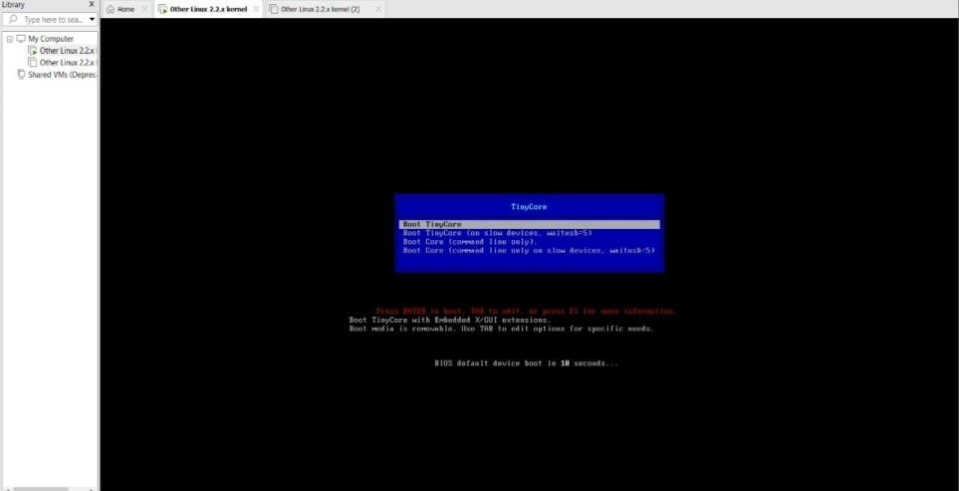
Output:
Expno 8: Create A Virtual Machine With 1 Cpu, 2gb Ram And 15gb Storage Disk Using A Type 2 Virtualization Software.

Date:

Aim:
To Create A Virtual Machine With 1 Cpu, 2gb Ram And 15gbstorage Disk Using A Type 2 Virtualization Software.
Procedure:
Step 1:Dowload Vmware Workstation And Installed As Type 2hypervisor.
Step2:Dowload Ubuntu Or Tiny Os As Iso Image File. Step 3: In Vmware Workstation->Create New Vm. Step 4: Do The Basic Configuration Settings.
Step 5: Created Tiny Os Virtual Machine. Step 6: Launch The Vm. Output: Created Tinyos Virtual Machine
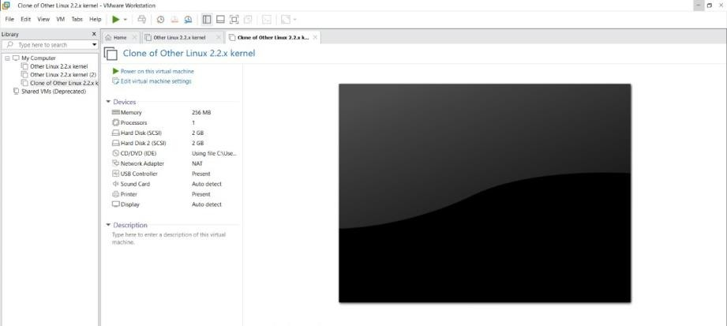

Exp 9: Create A Virtual Hard Disk And Allocate The Storageusing Vm Ware Workstation.

Date:

Aim:
To Create A Virtual Hard Disk And Allocate The Storage Using Vm Ware Workstation

Procedure:
Step 1:Goto Vm Ware Workstation.
Step2: Right Click The Vm And Goto The Settings.
Step 3: Add Hardware Wizard And Select Scsi And Click Next.
Step 4: Create New Virtual Disk.
Step 5: Selct The Disk Size As 2.0. And Selct Split Virtual Disk Intomultifiles.
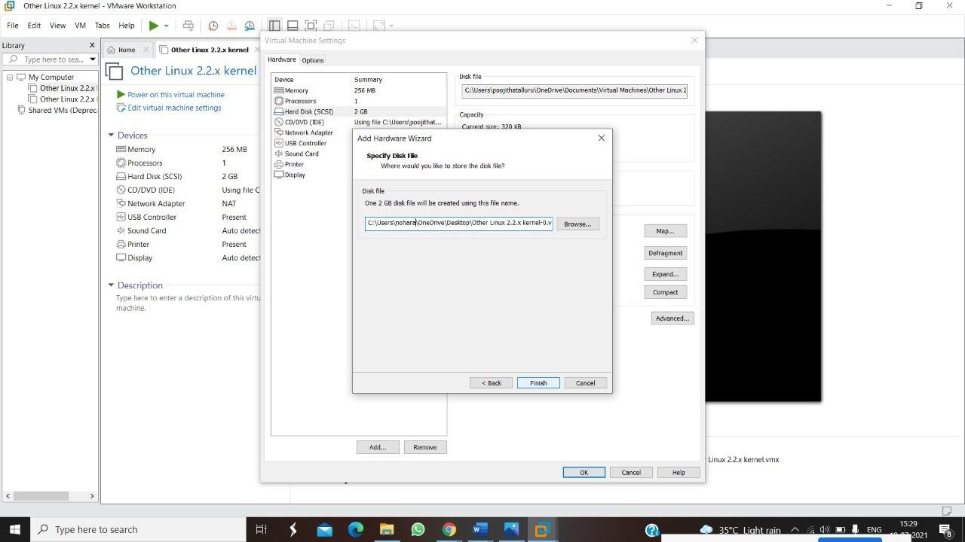
Step 6: Give Name And Click The Finish.

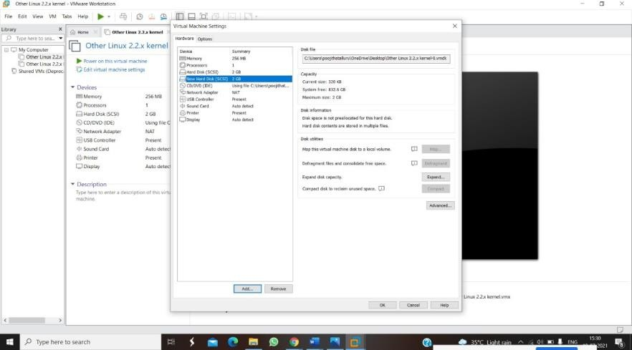

Expno 10: Create A Snapshot Of A Vm And Test It By Loading The

Previous Version/Cloned Vm

Date:

Aim:
To Create A Snapshot Of A Vm And Test It By Loading The Previous Version/Cloned Vm

Procedure:
Step 1: Goto Vmware Workstation. Step 2: Create Files On Desktop.
Step 3: Click On Vm And Selects Snapshot-> Take Snapshot.
Step 4: Snapshot Is Being Done
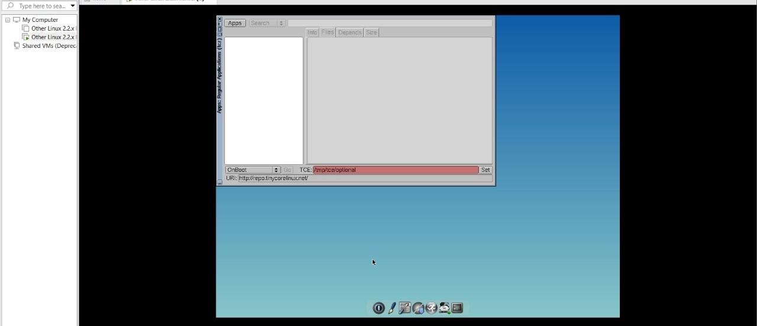

Expno 11: Create A Cloning Of A Vm And Test It By Loading The Previous Version/Cloned Vm.

Date:

Aim:
To Create A Cloning Of A Vm And Test It By Loading The Previous Version/Cloned Vm.

Procedure:
Step 1: Go To Vm And Goto Manage And Click Clone
Step 2: Click Clone
Step 3: Select The Full Clone
Step 4: After Clone Again Or Vm Is Opened.
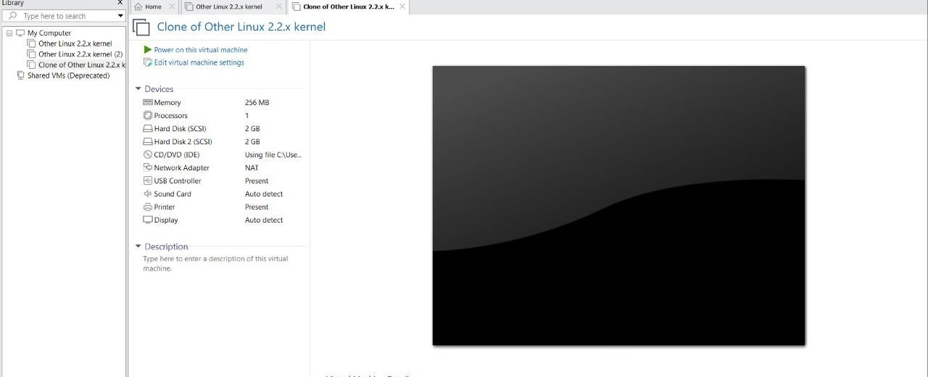

Exp 12: Change Hardware Compatibility Of A Vm (Either By Clone/Create New One) Which Is Already Created And Configured.

Aim:
To Change Hardware Compatibility Of A Vm (Either By Clone/Create New One) Which Is Already Created And Configured.

Procedure:
Step 1:Goto Vm Ware Workstation.
Step2: Right Click The Vm And Goto The Settings.
Step 3: Add Hardware Wizard And Select Scsi And Click Next.
Step 4: Create New Virtual Disk.
Step 5: Selct The Disk Size As 2.0. And Selct Split Virtual Disk Intomultifiles.
Step 6: Give Name And Click The Finish.





